Sennheiser helps shape the future of DECT NR+ audio at DECT World 2026
The audio specialist’s experts will share insights into spectrum, research and real-world audio applications, as DECT Forum announces new Audio Interest Group

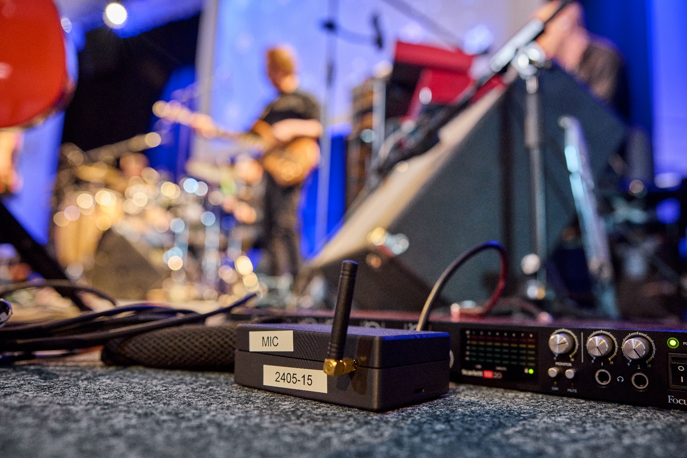

Wedemark, Germany, 27 October 2026 – At DECT World 2026, taking place in Munich on November 3 and 4, Sennheiser will underline its long-standing commitment to advancing DECT NR+ for audio through a series of expert contributions, alongside the launch of the DECT Forum’s new Audio Interest Group (AIG), which will be announced by Dr. Andreas Wilzeck, Head of Spectrum Policy and Standards at Sennheiser and member of the DECT Forum Board of Directors. As one of the key audio companies driving the future of DECT NR+, Sennheiser is helping to advance the technology, standards and ecosystem needed for next-generation wireless audio.

Sennheiser expert contributions at DECT World 2026
Ahead of the main conference, Wilzeck will give an introduction to DECT NR+ at the “Getting Started with NR+” pre-event on November 2, organised by the Opener Initiative. On November 4, Vaughan John, Spectrum Policy and Standards Manager at Sennheiser, will share the latest developments in DECT spectrum as part of an update from the DECT Forum’s Regulatory Working Group. Wilzeck will then review the first year of the Academia Industry Roundtable (AIR), an initiative he has chaired since its launch at DECT World 2025. AIR connects industry, universities and research institutions, allowing academic research and real-world industry challenges to inform one another.


From left to right: Sennheiser’s Dr. Andreas Wilzeck, Head of Spectrum Policy and Standards, Vaughan John, Spectrum Policy and Standards Manager, and Malte Lahrmann, Innovation Manager, will share insights into spectrum, research and real-world audio applications of DECT NR+ at DECT World 2026

In the conference’s audio block on November 4, Malte Lahrmann, Innovation Manager at Sennheiser, will explain why DECT has been part of Sennheiser’s Audio for Video solutions from an early stage and will outline the potential of DECT NR+ for these applications. Later in the same session, Wilzeck, as a member of the DECT Forum Board of Directors, will formally launch the Audio Interest Group.

One standard, many audio applications
The DECT Forum’s new Audio Interest Group (AIG) aims to bring together manufacturers, technology providers and experts to develop NR+ as a wireless connectivity platform for headphones, headsets, microphones, loudspeakers, intercom, conference and tour-guide systems, and other professional audio solutions. In doing so, the AIG responds to growing demand for reliable wireless connectivity, low-latency performance, spectrum efficiency, multi-device scalability and cross-vendor interoperability. By coordinating activities across the industry, its aim is to encourage the adoption of NR+ while avoiding market fragmentation in both professional and consumer applications. The group will organise its work across three areas: ecosystem development and marketing, certification, and guidance for migration from legacy DECT technologies to NR+. The AIG’s work builds on NR+’s ability to operate across multiple frequency bands below 6 GHz, with the almost globally available 1.9 GHz DECT band providing an important foundation.

“Wireless audio is becoming more demanding, and the spectrum it relies on is becoming increasingly crowded,” says Wilzeck. “A standard really proves its value when manufacturers, integrators and users can be confident that products will work together. The Audio Interest Group gives the industry a place to achieve that for NR+ audio, from certification to a clear migration path for existing DECT installations.”

Sennheiser’s presence at DECT World builds on the company’s work in standardisation and collaborative research. Wilzeck is Vice-Chair of ETSI TC DECT and led the MERCI consortium, a Franco-German innovation project focused on DECT NR+. At MERCI’s final workshop at Sennheiser’s headquarters in Wedemark in 2025, Sennheiser and RFmondial demonstrated a DECT NR+ wireless microphone with a cloud-connected production workflow.

“DECT NR+ will only reach its full potential in audio if spectrum, standards, research and products move forward together,” Wilzeck concludes. “Sennheiser is contributing in each of these areas, and we hope DECT World will encourage many more audio companies to get involved.”

DECT World 2026 takes place at the Eurostars Grand Central in Munich, Germany. For the full programme and registration, visit the DECT World 2026 website: https://www.dect.org/events/dect-world-2026/

(Ends)

The images accompanying this media release can be downloaded here.

About the Sennheiser brand
We live and breathe audio. We are driven by the passion to create audio solutions that make a difference. Building the future of audio and bringing remarkable sound experiences to our customers – this is what the Sennheiser brand has represented for more than 80 years. While professional audio solutions such as microphones, meeting solutions, streaming technologies and monitoring systems are part of the business of Sennheiser electronic SE & Co. KG, the business with consumer devices such as headphones, soundbars and speech-enhanced hearables is operated by Sonova Holding AG under the license of Sennheiser.

www.sennheiser.com
www.sennheiser-hearing.com

Global Press Contacts
Jacqueline Gusmag
Jacqueline.gusmag@sennheiser.com
+49 (5130) 600 – 1275

